Full Body Picture
معلومات شخصية Information Personal
Nationality | {nationality} |  | اﻟﺟﻧﺳﯾﺔ
Date of Birth |  |  | ﺗﺎرﯾﺦ اﻟﻣﯾﻼد
Address |  |  | اﻟﻌﻧوان
Marital Status |  |  | اﻟﺣﺎﻟﺔ اﻻﺟﺗﻣﺎﻋﯾﺔ
No. of Children |  |  | ﻋدد اﻷطﻔﺎل
Height/Weight | {height} | {weight} | اﻟوزن واﻟطول
Education Qualifications |  |  | اﻟﻣﺳﺗوى اﻟﺗﻌﻠﯾﻣﻲ
Tel. Number | {phone} |  | رﻗم اﻟﺗواﺻل

خبرات سابقة Experience Overseas
Country | Period | Date
 | {workPeriod}
 |  | N/A

المهارات Skills
Cooking | NO | اﻟطبﺦ | Baby  Sitting |  | اﻟﺗﻌﺎﻣل ﻣع اﻷطﻔﺎل
Washing |  | اﻟغﺳﯾل | Sewing | NO | اﻟﺧﯾﺎطﺔ
Cleaning |  | اﻟﺗﻧظﯾف | Driving | NO | ﺳﺎئق

Languages |  | اﻟﻠغﺎت
اﻹﻧﺟﻠﯾزﯾﺔ English |  | Arabic | اﻟﻌربﯾﺔ
Good |  | NO | ﺟﯾد
Fluent |  | NO | ﻣﻣﺗﺎز

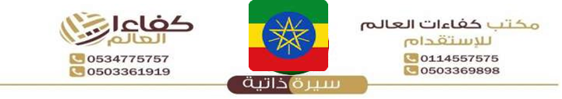
 | Reference Number
 | Full Name |  | اﻻﺳم
 | Religion |  | اﻟدﯾﺎﻧﺔ
 | Position Desired | {position} | اﻟوظﯾﻔﺔ
 | Salary | {salary} | اﻟراﺗب
 | Age |  | اﻟﻌﻣر
 | Sex | {gender} | اﻟﺟﻧس
معلومات الجواز Information Passport
Number | EP
Issue Date |  | اﻹﺻدار
Expiry Date |  | اﻻﻧﺗﮭﺎء
Issue place |  | اﻹﺻدار
Next of Kin name |  | ﺧص
Next of Kin | {phone} | ﻘرﯾب
number

Remarks: SHE IS HARDWORKING, NEAT, ORGANISED, SMART, DISCIPLINED, CARING, HAS A GOOD ATTITUDE, SPEAKS GOOD ENGLISH AND LOVES TAKING CARE OF CHILDREN.

